**LEBANESE AMERICAN UNIVERSITY**

**USAID – HIGHER EDUCATION SCHOLARSHIP PROGRAM**

**HES - Volunteering Program Verification Form**

This form is to be used to document volunteering hours. If a student volunteers for multiple organizations, a separate form must be used for each organization. **This form must be turned in by the 28th of each month, the latest.**

I certify that the scholar Leonard Marida completed a total of 5 hours of service at Life Sculptor.

The hours were completed hours as per the below:

Hours # 0 (date) _30/09 – 5/10_ (initials of supervisor) __A.K.___

Hours # 0 (date) _7/10 – 11/10_ (initials of supervisor) __A.K.___

Hours # 5 date) _14/10 – 18/10 (initials of supervisor) __A.K.___

Hours # 0 date) _21/10 -25/10 (initials of supervisor) __A.K.___

Brief description of the activities the scholar performed or participated in:

I conducted research on biohacking and wearable health tech, focusing on wearable health tech in action, including hands-on demonstrations of wearable health tech devices and discussions on data tracking, analysis, and interpretation using these devices. I explored strategies for incorporating biohacking techniques into daily routines and provided tips for selecting and using wearable health tech effectively. Additionally, I examined biohacking for performance enhancement, discussing techniques for optimizing physical and cognitive performance as well as the ethics and implications of performance enhancement biohacks. The research also covered the relationship between biohacking and personalized medicine, discussing how biohacking can inform personalized health interventions with case studies and examples of personalized health approaches using biohacking techniques. Lastly, I outlined strategies for using biohacking techniques to optimize health and well-being.

Written feedback about the scholar’s performance:

Leonard demonstrates solid research abilities and a good understanding of emerging topics like biohacking and wearable technologies. He shows a willingness to engage with complex ideas and explore their practical applications. While there is room for further development in critical thinking and communication, Leonard’s interest in cutting-edge technologies reflects a growing strategic mindset and potential for future growth.

Please rate the overall performance of the scholar at your organization:

|  |  |  |  |
| --- | --- | --- | --- |
|  | Mastery (5) | Proficient (3) | Emerging (1) |
| **Problem solver** | X |  |  |
| **Engaged & Committed** | X |  |  |
| **Open-minded & multicultural** | X |  |  |

Signature

& stamp

__________________________

_

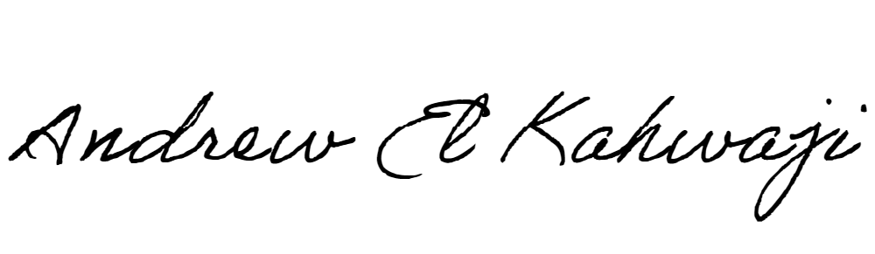

Printed Name _Andrew El Kahwaji_

Date __26/10/2024___

Email __andrew.lifesculptor.coo@gmail.com __

Phone __+961 71 914 378__

**LEBANESE AMERICAN UNIVERSITY**

**USAID – HIGHER EDUCATION SCHOLARSHIP PROGRAM**

